
PHILIPPINE GENERAL HOSPITAL
OUT PATIENT DEPARTMENT
SECTION OF ALLERGY AND IMMUNOLOGY

Urticaria
Follow up Form

PERSONAL DATA
Patient’s Name _______________________________________________________ Case No ________________
Age ______ Sex ______ Status _______ Date Data was Taken_____________________
Birthday _______________________ Birthplace ______________________________
Address ________________________________________________________________ Contact No ______________
Source of Referral ___________________________ Informant _________________________ Reliability _______%
----------------------------------------------------------------------------------------------------------------------------------------------------------------

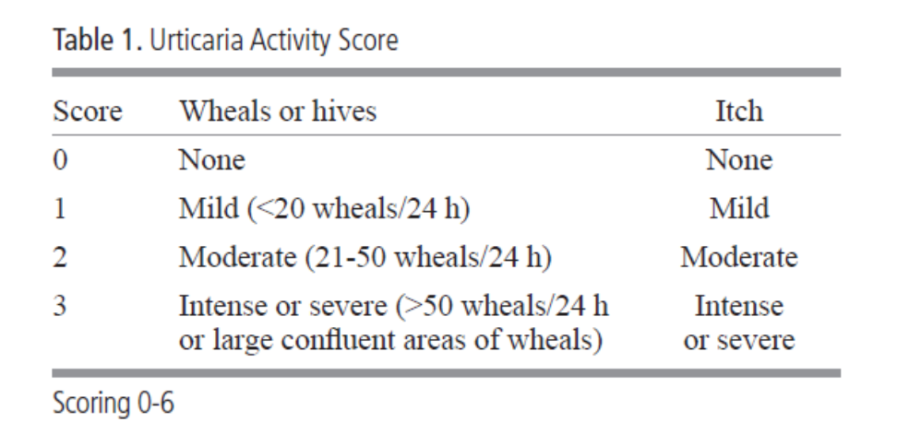

*Should be used for at least 4 consecutive days , preferably one week.

Treatment:

Medication Dose Frequency
(generic/brand name) (mg/tablet or syrup) (per day)

H1-Antihistamine
1.
2.
3.
4.
5.

H2-Antihistamine

Leukotriene antagonist

Steroid:

Others:

Procedures: Reading Interpretation

ASST: result: negative control:
Serum:
Response after __ weeks
Elimination diet: Modified elimination diet
Total elimination diet
Others

Food Challenge:

Food Skin Test: link

